PRAYER IN C LILLY WOOD
http://www.youtube.com/watch?v=fiore9Z5iUg
1 1 4
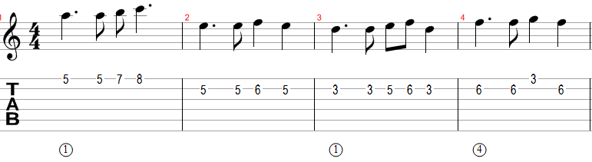

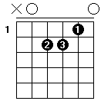
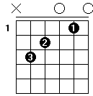
1ET(2)ET3ET(4)ET Am C
12ETET1
Am C
Yeah, you never said a word
G
You didn't send me no letter
Dm
Don't think I could forgive you
Am C G Dm
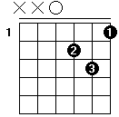
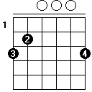
See our world is slowly dying
G
I'm not wasting no more time
Dm
Don't think i could believe you

INTRO: Am C G Dm Am C G Dm

Rejouer le marron

Am C G
Yeah, our hands will get more wrinkled and our hair will be grey
Dm Am C
Don't think i could forgive you and see the children are starving
G Dm
And their houses were destroyed don’t think they could forgive you
Am C
Hey, when seas will cover lands
G
And when men will be no more
Dm
Don't think you can forgive you
Am C
Yeah when there'll just be silence
G
And when life will be over
Dm
Don't think you will forgive you

PONT: Am C G Dm

Am C
Yeah, You never said a word
G
You didn't send me no letter
Dm
Don't think I could forgive you
Am C
See our world is slowly dying
G
I'm not wasting no more time
Dm
Don't think i could believe you

Intro: Am C G Dm Am C G Dm

Rejouer le marron

Am C
Yeah, our hands will get more wrinkled
G
And our hair will be grey
Dm
Don't think i could forgive you
Am C
And see the children are starving
G
And their houses were destroyed
Dm
Don't think they could forgive you

Am C
Hey, when seas will cover lands
G
And when men will be no more
Dm
Don't think you can forgive you
Am C
Yeah when there'll just be silence
G
And when life will be over
Dm
Don't think you will forgive you
/…………………………….
4 POUM TCHAC POUR UN ACCORD
12ETET1 ou 1et2et3et4et

